- System Design II: Behavior Models
Genius is 1% inspiration and 99% perspiration.—Thomas Edison

The functional decomposition technique examined in Chapter 5 is a powerful modeling tool for system design that is applicable for describing input, output, and transform behavior. However, that approach by itself is limited in its descriptive ability. This was apparent in the digital stopwatch example that required the use of state diagrams, in addition to functional decomposition, to fully articulate the design. A state diagram is an example of a model, a standardized abstraction of a system. Models allow systems to be described without having to determine all of the implementation details. All models are not the same—they come in a variety of forms and each serves a different intention.
This chapter provides an overview of other design tools for describing system behavior, with an emphasis on computing systems. The first tool examined is the state diagram. This is followed by the flowchart, which describes algorithmic processes and logical behavior. Two modeling languages for information and data handling—data flow diagrams and entity relationship diagrams—are then examined. The final is the Unified Modeling Language, which is a collection of system views for describing behavior.
Learning Objectives
By the end of this chapter, the reader should:
- Be familiar with the following modeling tools for describing system behavior: state diagrams, flowcharts, data flow diagrams, entity relationship diagrams, and the Unified Modeling Language.
- Understand the intention and expressive power of the different models.
- Understand the domains in which the models apply.
- Be able to conduct analysis and design with the models.
- Understand what model types to choose for a given design problem.
  - Models
From the previous chapter we know that the top-down design process starts with an abstraction of the system to be built. This initial design is called an abstraction because it captures the essential characteristics of the system without specifying the underlying physical realization. An abstraction that is expressed in a standardized and accepted language is called a model. In other words a model is a standardized representation of a system, process, or object which captures its essential details without specifying the physical realization. A modeling language does not have to be formed from letters and words—often the words are graphical symbols. You are already familiar with many different models from everyday life such as blueprints, a diagram of a football play, knitting instructions, electrical schematics, and mathematical formulas to name a few. In order to be effective, a model should meet the following properties [Sat02]:
- Be abstract. This means that the model should be independent of final implementation and that there should be multiple ways of implementing the design based upon it.
- Be unambiguous. A model should have a single clear meaning in terms of describing the intended behavior.
- Allow for innovation. Models should encourage exploration of alternative system implementations and behaviors.
- Be standardized. Standardization provides a common language that can be understood by all. Designers should be wary of developing their own models that are ill-defined and not commonly understood.
- Provide a means for communication. A model should facilitate communication within the design team and with non-technical stakeholders.
- Be modifiable. A model should make design modifications relatively easy.
- Remove unnecessary details and emphasize important features. The intent is to simplify the design for ease of understanding. The most highly detailed information is typically identified in the detailed design.
- Break the overall problem into sub-problems. Most problems are too complex to be handled directly and must be decomposed into subsystems. This produces the design hierarchy.
- Substitute a sequence of actions by a single action. This allows understanding of the overall larger behavior, which can then be examined at other levels. This supports the ability to break a design into sub-problems.
- Assist in verification. A model should aid in demonstrating that the design meets the engineering requirements.
- Assist in validation. Validation is the process of demonstrating that the needs of the user are being met and the right system is being designed. The model should facilitate discussion with all stakeholders to ensure it meets everyone’s expectations.
In order to meet these properties, most models have an object type, which is capable of encapsulating the actual components used to construct the target system. In order to capture the dependence of objects on one another models typically have a relationship type. Finally, models have an intention, which is the intended class of behavior that it describes. For example, the intention of a circuit schematic and the schematic of a football play are entirely different. Since models are built with different intentions, it possible to choose the wrong model for a particular system—it would surprise a football team to see a play represented with resistors and capacitors!
Since models capture the essential details of a system in a standardized way then they are an ideal way to describe the functionality of a system at all levels of detail. In Chapter 5 the predominate method of describing functionality was with words. However, there are languages that describe system behavior. We start by examining state diagrams.
  - State Diagrams
State diagrams describe the behavior of systems with memory. A system with memory is able to modify its response to inputs based on the state of the system. The state of a system represents the net effect of all previous inputs to the system. Since the state characterizes the history of previous inputs, it is often synonymous with the word memory. Intuitively, a state corresponds to an operating mode of a system, and inputs are associated with transitions between states. To determine if a system has memory, ask the following question— “Can the same input produce different outputs?” If the answer to this question is yes, then the system has memory and can be modeled with a state diagram.
A state diagram is a drawing that consists of states and transition arcs as shown in Figure 6.1. Each state is represented as a rectangle with rounded edges with the name of the state written inside. Whenever possible, states should be given meaningful names. When there exists the possibility for ambiguity in the names, a table should be created that identifies the state names and their associated meanings. There are special circle symbols for both initial and final states. Transitions are drawn as arrows from a source state to a destination state. Since inputs cause the transitions between states, the arrows are labeled with their associated inputs. The outputs are listed directly in the state since it is assumed that the outputs are associated with states.

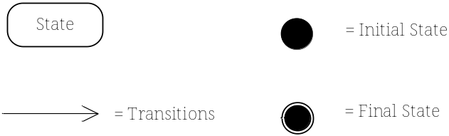
Figure 6.1 Symbols used in state diagrams.
As an example, consider a vending machine that accepts nickels and dimes and dispenses a piece of candy when 25 cents has been deposited. This vending machine can be modeled using a state diagram because the response of the machine to a coin depends on how much money has been deposited so far.
In order to give a more complete description of the vending machine the state diagram is embedded into the function table template introduce in Chapter 5as shown in Figure 6.2. This table lists the inputs and outputs of the vending machine along with the behavior represented by a state diagram.
Module | Vending Machine Control Unit
Inputs | - Nickel: Signals that a nickel has been deposited.  - Dime: Signals that a dime has been deposited.
Outputs | - Reset: Signals the FSM to return to the Initial/Reset state.  - Vend: Signal to dispense candy.
Functionality | 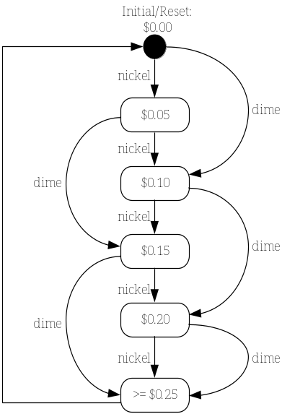
Figure 6.2 A state diagram for a simple vending machine.
The initialization/reset state is labeled $0.00, while the action of the machine (dispense or not dispense candy) is associated with the states—the only state that dispenses candy is $0.25. There are three types of transitions shown in this state diagram. The two labeled nickel and dime are associated with depositing those coins. The unlabeled transition from state $0.25 to state $0.00 is called an unconditional transition. A system with an unconditional transition between two states is assumed to remain in the first state for a defined time period before automatically moving to the second state. In this case it ensures that the machine dispenses a single candy before going on to the next transaction. It is common practice in state diagrams to assume that any unspecified input conditions cause the system to remain in the current state. For example, if no coin is inserted while in state $0.20 the system remains in state $0.20. Finally, note that since this machine does not dispense change, it can overcharge a customer for candy. This would not be a popular vending machine with users!
  - Flowcharts
The intention of a flowchart is to visually describe a process or algorithm, including its steps and control. Flowcharts are often scoffed at as being old-fashioned and overly simple—these criticisms are actually strengths. Since flowcharts have been around for a long time, they are easily recognized and understood. Furthermore, being simple makes them accessible to a wide audience. Due to their simplicity, they are applied in a great number of applications, including non-technical ones such as the description of business processes.
Some of the primary symbols used in flowcharts are shown in Figure 6.3. The names of the starting and ending steps of a flowchart are represented by ovals known as terminators. Individual processing steps are written inside of rectangles, while a process step that is elaborated by another flowchart is drawn as a rectangle with double sides. Elaborated processes allow the representation of hierarchy in the design. Certain points in a flowchart can lead to alternative destinations as represented by a decision or conditional symbol (diamond). The condition that determines the next step is written inside the diamond and the possible values of the condition are written on the arcs leaving the conditional step. As shown in Figure 6.3 there are multiple ways to indicate data stores for retrieving or saving data.
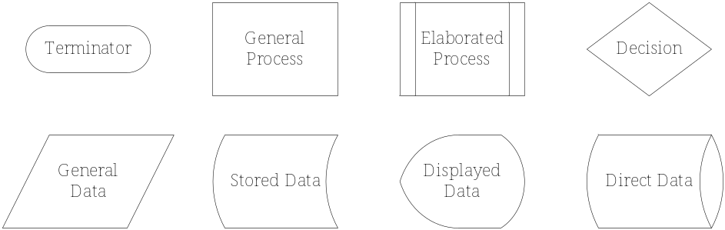
Figure 6.3 Basic flowchart symbols.
As an application, consider an embedded computer system that monitors the light level of its environment as described by the flowchart in Figure 6.4. The algorithmic process of the flowchart is easy and intuitive to understand. The system reads the current light value, stores it into an array, and then computes an average. In a complete system description, there would be a second flowchart describing how the system determines the average of the values of the light samples, since this is identified as an elaborated process. The system then waits 1ms, writes the average to a terminal (display device), and then checks for a key-press. Light levels continue to be monitored in the absence of a key-press, otherwise the light monitoring process halts.

Module | Light level data logger
Inputs | - Light intensity: Ambient light intensity from environment.  - Key-press: User request to abort data logging.
Outputs | - Terminal: Displays the average light intensity.  - Disk: Stores a record of light intensities through time.
Functionality | 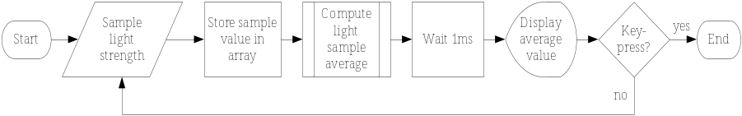
Figure 6.4 A flowchart for an embedded system.
Flowcharts are an intuitive way to describe algorithmic processes. Limiting the complexity of a flowchart to between 10 and 20 steps enables the sequence of actions to be quickly comprehended while eliminating unnecessary details. Flowcharts are not able to represent the structure of data being manipulated and they are not particularly good at representing concurrent processes. For this we need data flow diagrams.
  - Data Flow Diagrams
The intention of a data flow diagram (DFD) is to model the processing and flow of data inside a system. It is a function-oriented approach that is similar to functional decomposition—the processes inside a DFD accept data inputs, transform them in some way, and produce output data. A DFD is often used for the analysis of information systems due to its data emphasis, but can be broadly applied to ECE systems. It differs from functional decomposition in that functional decomposition is often closer to the implementation of the design, whereas the DFD models the system from a data point of view. A DFD is fundamentally different from a flowchart in that it does not encapsulate control and sequencing information, but allows multiple processes running concurrently. There are four symbols, shown in Figure 6.5, that are used in a DFD:
- Processes. A rectangle with rounded corners that describes a useful task or function. They perform a transformation on the data.
- Data flows. An arrow representing a data relationship between two processes.
- Data stores. An open rectangle representing a data repository.
- Interfaces. A square describing external agents or entities that use the system. They are also referred to as sources and sinks.
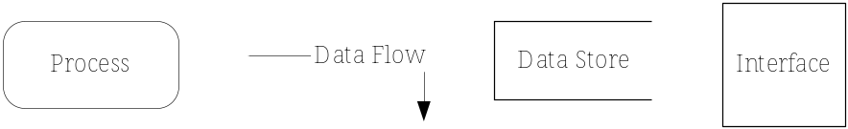
Figure 6.5 Data flow diagram symbols.
Like the general design process, DFDs are successively refined from the top-down. That is, there is a single top level (or Level 0) DFD describing the entire system and the interfaces and data stores that it interacts with. The rules for constructing a DFD are fairly intuitive. A process must have at least one input and one output. The refinement of a process at level N must have the same inputs and outputs as the process at level N-1. Data must be transformed in some way by a process. This process of refinement continues until a satisfactory level of detail is reached.
An example of a Level 1 DFD for a video browsing system is shown in Figure 6.6. Video databases are typically very large; due to their size, it is usually cumbersome to preview videos and extract important information. A solution to this problem is to apply image analysis techniques to identify shots (continuous scenes without a break) in a video and store both the location of the shot boundaries in the video and key frames that summarize each shot. The collection of key frames is known as a storyboard. The storyboards are stored in an annotation database that is much smaller in size than the original video database. Typically the user of a video browsing system has the ability to preview the storyboard and select shots from it to view. This example shows the data flow for such a system.
The data processing is readily apparent from the DFD. Videos in the database are processed to extract shot boundaries and key frames, which are stored in the annotation database. The user can submit requests to view a storyboard, which is retrieved from the annotation database. When a shot is selected from the storyboard, the users can preview the original shot, which is retrieved from the video database.

Module | Video Browsing System
Inputs | - Video: External video to the system that is entered into the video database.  - Browse Request: User request to browse a particular video.  - Shot Preview Request: User request to preview a particular short from a video.
Outputs | - Story Board: A sequence of frames summarizing the entire video.  - Shot: The complete video corresponding to the still image in the story board.
Functionality | 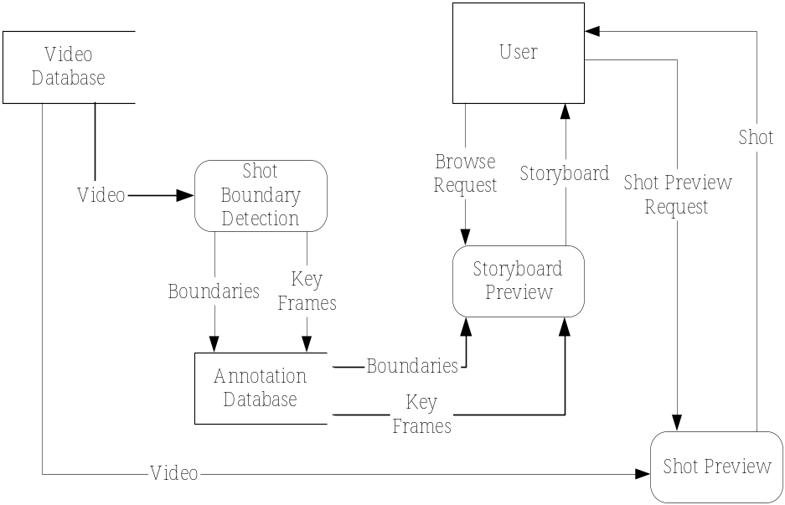
Figure 6.6 Level 1 data flow diagram for a video browsing system.
There are a few important points to note about DFDs. They are solution independent, specifying the behavior based upon data flow. Specific information on the data flows is defined in a formal language known as a data dictionary (it is not covered here). There can be concurrent processes represented in a DFD. In the video browsing example, multiple people can use the system simultaneously, and there is no implied sequencing between when the shot boundary detection process is run and the storyboards are previewed. It is clear that the video must undergo shot detection prior to viewing its storyboard. This information is listed in something known as an event table. The event table for this example is shown in Table 6.1.
Table 6.1 Event table for the video browsing system.
Event | Trigger | Process | Source
Annotate Video | New Video Arrival | Shot Boundary Detection | System
View Storyboard | Browse Request | Storyboard Preview | User
View Shot | Shot Preview Request | Shot Preview | User

An event is an occurrence at a specific time and place that needs to be remembered. Events can be classified into temporal, external, and state. A temporal event is one which happens because the system has reached some critical time. In this example, the generation of shot boundaries could occur for all new videos in the database at a specified time each day, but in this case it occurs whenever a new video is added to the database. An external event occurs outside the system boundary by a system user, in this case requesting either a storyboard or a video preview. A state event is the result of something changing within the system. Associated with each event is a trigger, the cause of the event. Each event has a process that is associated with it. Finally, associated with each event is a source, the entity responsible for triggering it.
  - Entity Relationship Diagrams
A database is a system that stores and retrieves data, and it is modeled by an entity relationship diagram (ERD). The intention of an ERD is to catalog a set of related objects (entities), their attributes, and the relationships between them. The entities and their relationships are real distinct things that have characteristics that need to be captured. The design of a database starts by describing the entities, their attributes, and the relationship between entities in an ERD. In order to ask meaningful questions about the data, the entities need to be related to one another. For example, a list of students and a list of courses by themselves have limited utility. However, by introducing a relationship between these two entities we can ask questions such as “How many students are taking the Microelectronics course?” The three elements used in the ERD modeling language are:
- Entities. They are generally in the form of tangible objects, roles played, organizational units, devices, and locations. An instance is the manifestation of a particular entity. For example, an entity could be Student while an instance would be Kristen.
- Relationships. They are descriptors for the relationships between entities.
- Attributes. They are features that are used to differentiate between instances of the entities.
Lets consider an ERDs describing academic life at a college . The process typically starts by interviewing the end-users and identifying the entities and their attributes. Assume that the result of this process is that the college wants to store data about three entities: Students, Courses, and Departments. The process of building an ERD starts by determining the relationships between entities. One way to do this is to build an entity relationship matrix as shown in Table 6.2. The entities constitute both the row and column headings, and the matrix entries represent the relationship, if any, that exists between entities. This is similar to the pairwise comparison matrix in Chapter 2 where user needs were systematically compared. Relationships are bi-directional because they have two participating entities.
Table 6.2 Entity relationship matrix.
 | Student | Course | Department
Student |  | takes many | majors in one
Course | has many | can require many / can be the prerequisite for many | is offered by one
Department | enrolls many | offers many

From Table 6.2 we can see that a Student can take many courses and a Course has many students in the Student-Course relationship. A cardinality ratio, associated with each relationship, describes the multiplicity of the entities in a relationship. For example, the Student-Course relationship is many-to-many, or M:M, because one student can take many courses and one course is taken by many students. The relationship between Student and Department is M:1 since a Department enrolls many students, but a student can major in only one Department. A recursive relationship, prerequisite, exists between the Course entity and itself because a course may have many other courses as prerequisites and may be the prerequisite for many other courses. Thus the prerequisite relationship has an M:M cardinality. It needs to be noted that in this example the needs of the college required relationships between all pairs of entities. If, for example, the college did not need to keep track of the students’ majors, then the relationship between Student and Department would be left blank in the entity relationship matrix.
The resulting ERD is shown in Figure 6.7. The relationships are identified by the diamonds shaped symbols; the entities are denoted by the rectangles with their name at the top. The cardinality ratio is labeled on the links between the relationships and entities. Another piece of information shown in the ERD is the attributes associated with each entity. An attribute is a feature or characteristic of an entity that needs to be remembered. There are many different types of attributes; however, the most important are key attributes (which are underlined) which uniquely identify instances. For example, the identification number (ID) attribute of a Student is a key attribute.

Module | Grade Database
Inputs | - Students: Data about students.  - Departments: Data about departments.  - Courses: Data about courses.
Outputs | - Relationship between departments and their enrolled students.  - Relationship between students and the courses that they take.  - Relationship between departments and the courses they offer.  - Relationship between course and their prerequisite courses.
Functionality | 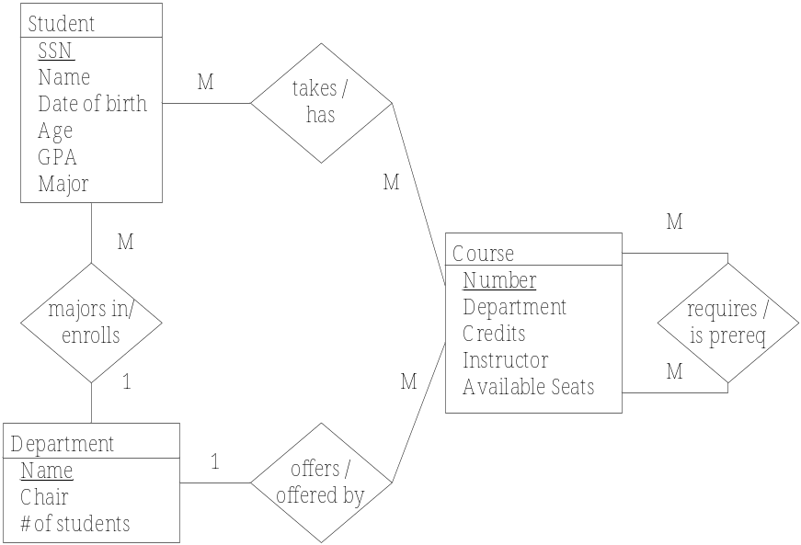

Figure 6.7 ERD for the college database system.
The ERD allows for an easy interpretation of the relationships between entities as well as their attributes. Although beyond the scope of the discussion here, the ERD is a formal language that can be used to automatically generate the database structure. The relationships in the ERD allow queries to be asked of the resulting database. For example, the college could derive a student’s course schedule from the database from the relationship between Student and Course.
  - The Unified Modeling Language
The Unified Modeling Language (UML) was created to capture the best practices of the object-oriented software development process. However, it has valuable modeling tools that can be applied more generally to ECE systems. The objective of this section is to provide an overview of UML and the six different system views that it encompasses. A caveat for the reader—UML is complex, and complete coverage is beyond the scope of this book. In order to fully understand its subtleties and nuances, the reader is advised to consult the references provided in Section 6.8.
In order to aid in the explanation of the different views we will create a UML model of a system called the Virtual Grocer, or v-Grocer for short. The v-Grocer enables a user to order groceries from home and have them delivered. The concept is to provide users with a barcode scanner that is connected to their home computer along with application software. When the user runs out of an item, he/she scans in the Universal Product Code (UPC). When users want to order groceries, they connect to the Internet, log into the grocery store web server, enter the quantity for the scanned items, and place their order. Once the order is completed, they are billed and the groceries are delivered to their houses at a prearranged time.

Static View
Object-oriented design (OOD) is fundamentally different from functional software design in that it emphasizes objects instead of functions. Objects represent both data (attributes) and the methods (functions) that can act upon the data. An object represents a particular instance of something known as a class, which defines the attributes and methods. An object encapsulates all of this information. The data and methods that an object encapsulates are available only to that object by default. Thus, other objects cannot change that state of an object unless given specific permission to do so. This improves the reliability and maintainability of software systems, because changes made to the internal representation of a class are not seen by methods outside of the class.
The intention of the static view is to show the classes in a system and their relationships. The static view is characterized by a class diagram. A very simple class diagram with a single class is shown in Figure 6.8. The specification of a class has three parts, a name, a list of attributes, and a set of methods. The name of the class for this example is Customer and it has three attributes: Name, Address, and CustId. It has one method associated with it, ChangeAddr(), which can change the Address attribute. A class, just like an entity in an ERD, is a generalization of a set of a particular thing or instance. For example, the Customer class could have a particular instance called Ms. Robinson.

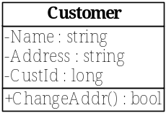
Figure 6.8 Class diagram notation. The class has a label (Customer), attributes (Name, Address, and CustId), and methods (ChangeAddr()).
Classes are related to one another by relationships that define how classes interact with each other. For example, if a class is a subset of another class (a kind of relation) then the subclass inherits all the attributes and methods of the superclass. In UML, there are a host of relationships; among these are generalization, composition, and associations. Two classes are related by a generalization relationship when one is a subset of the other. Two classes are related by a composition relationship when one is composed of members of the other. Two classes are related by an association relationship whenever they need to send messages to one another. Relationships are drawn as lines connecting the two participant classes. The terminals of the line have different shapes depending on the type of relationship. Just like an ERD, the relationships between classes have cardinality defined by the rule base. In order to illustrate these points, Figure 6.9 shows the class diagram for a portion of the v-Grocer system.

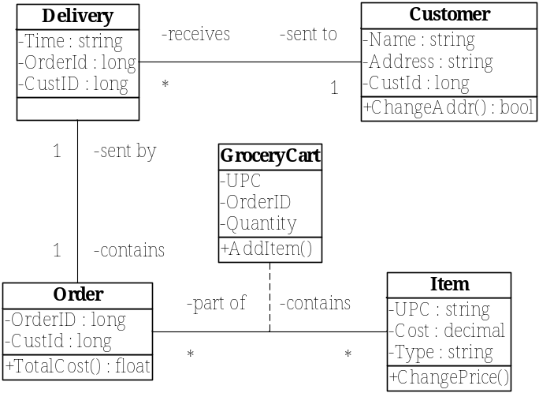
Figure 6.9 Class diagram for the v-Grocer.
The class diagram has five classes—Customer, Delivery, Order, Item, and GroceryCart. The GroceryCart class is derived from the many-to-many relationship which exists between the Order and Item classes. Just like the rules for an ERD, the cardinality of a relationship is read at the end of the association in which it is involved. The only difference is that the many cardinality in a class diagram is denoted by a * symbol. For example, a delivery is sent to one customer, while a customer may receive many deliveries.

Use-Case View
The intention of the use-case view is to capture the overall behavior of the system from the user’s point of view and to describe cases in which the system will be used. It is characterized by a use-case diagram, and an example for the v-Grocer is shown in Figure 6.10. There are only two symbols employed in a use-case diagram, actors and use-cases. Actors, drawn as stick figure people, are idealized people or systems that interact with the system. For this example the actors are customers, delivery people, the database, clerks, and the web server. Use-cases are drawn as ovals in the diagram, and in this example, they are WebOrder, DeliverOrder, and AssembleOrder. A use-case is a particular situation when actors use the system and is usually represented by a sequence of actions that will be performed by the system. This sequence of actions typically represents a high level of functionality. Every actor that interacts with a particular use-case is connected to it with a line. Finally, the entire collection of use-cases is enclosed in a rectangle with the actors outside. This rectangle represents the system boundary and consequently is labeled with the name of the system.

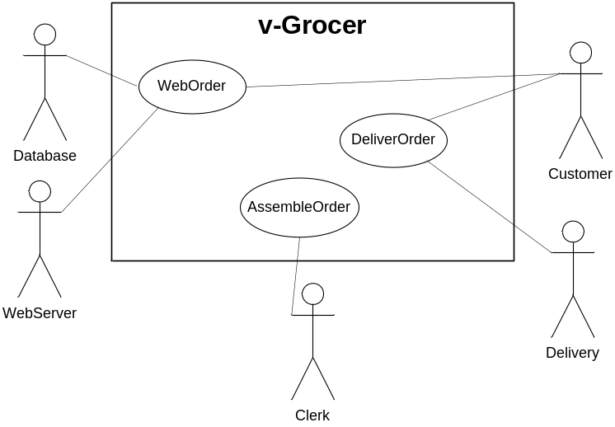
Figure 6.10 Use-case diagram for the v-Grocer.
From Figure 6.10 it is apparent that a Customer, the WebServer, and Database interact when creating a WebOrder. Use-cases are often described in a table as shown for this particular example in Table 6.3.
Table 6.3 WebOrder use-case description.
Use-Case | WebOrder
Actors | Customer, Database, and WebServer
Description | This use-case occurs when a customer submits an order via the WebServer. If it is a new customer, the WebServer prompts them to establish an account and their customer information is stored in the Database as a new entry. If they are an existing customer, they have the opportunity to update their personal information.
Stimulus | Customer order via the GroceryCart.
Response | Verify payment, availability of order items, and if successful trigger the AssembleOrder use-case.

Use-cases focus on a very high level of functionality and describe who will interact with the system and how they will interact. Given their high level of abstraction, they can easily be incorporated into a variety of ECE projects. They are also simple and easy to understand and thus can be incorporated into presentations to non-technical audiences. Finally, use-cases are simply not busy work—they are fundamental to the development of other UML models.

State Machine View
The state machine view is characterized by a state diagram as was discussed in Section 6.2. Again, the intention of a state diagram is to describe systems with memory. Figure 6.11 shows the state view of a customer logging into the v-Grocer web server.

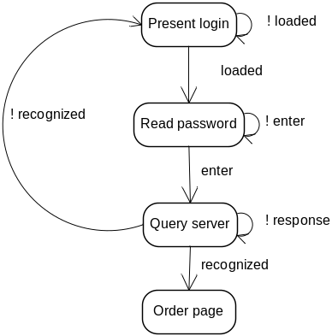
Figure 6.11 State diagram for the v-Grocer customer login.

Activity View
The intention of the activity view, characterized by an activity diagram, is to describe the sequencing of processes required to complete a task. In UML, the tasks elaborated are the individual use-cases identified in a use-case diagram. Since more than one actor may be involved in completing a task, an activity diagram can express the concurrent nature of tasks. An activity diagram is composed of states, transitions, forks, and joins. Figure 6.12 contains an activity diagram for the v-Grocer order delivery system. The diagram gives a clear visual picture for the activities that need to be completed for an order to be packed and delivered. After a complete order is placed, the flow is forked into two concurrent processing branches. One of these branches is for completion of the order, while the other addresses its scheduling, delivery, and coordination with other deliveries. When both of those processes are completed, they are joined together and then the delivery run is made.

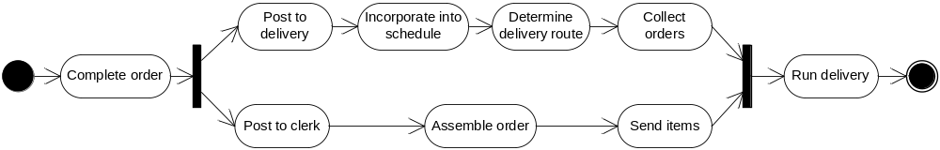
Figure 6.12 Activity diagram for order processing and delivery for the v-Grocer.

Interaction View
The intention of the interaction view is to show the interaction between objects. It is characterized by collaboration and sequence diagrams. In an object-oriented system, tasks are completed by passing messages between objects. The interaction view shows how messages are exchanged in order to accomplish a task. These tasks are usually the use-cases. Since messages are sent through time, the interaction view must be able to express the concept of order. We start by examining collaboration diagrams.
Two objects collaborate together in order to produce some meaningful result. A collaboration diagram shows the sequencing of messages that are exchanged between classes in order to complete a task. It consists of the classes that participate in the realization of the task and the messages exchanged. The messages are drawn as arrows from the sending object to the receiving object. The message arrows are labeled with the name of the message and its numerical position in the sequence of messages exchanged to realize the task. For example, Figure 6.13 shows how the WebOrder use-case is realized using the Customer, WebServer, and Database classes. Note, WebServer and Database are introduced as new classes and are not shown as part of the class diagram in Figure 6.9.

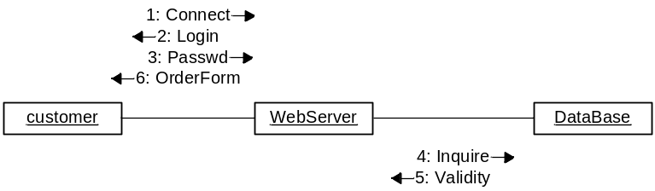
Figure 6.13 Collaboration diagram for the WebOrder use-case.
The collaboration diagram is similar in form to the class diagram, the difference being that the relationships are annotated with the messages that are exchanged. Consequently, the collaboration diagram aides the developers in understanding and implementing the methods used between classes. In order to emphasize the order in which messages are exchanged, a developer can also use a sequence diagram.
A sequence diagram contains the same information as the corresponding collaboration diagram. Where the collaboration diagram emphasizes the objects that interact to produce a behavior, a sequence diagram emphasizes the message order that produces a behavior. As shown in Figure 6.14, the classes that participate in the behavior are listed in a row at the top of the diagram. From each class a dotted vertical line is drawn downward that represents the lifeline of its class (the vertical axis represents time). When an object is actively requesting or waiting for information from another object, a rectangle is drawn over the dotted lifeline of the object. The message is drawn as an arrow from the sending object to the receiving object and labeled with the name of the message. The activity diagrams can be applied generally to ECE systems to show the interaction between entities, particularly the sequencing of messages.

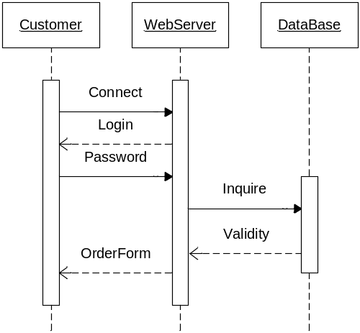
Figure 6.14 Sequence diagram for the WebOrder use-case.

Physical View
The intention of the physical view is to demonstrate the physical components of the system and how the logical views map to them. The physical view is characterized by a component and deployment diagram. A component diagram shows the software files and the interrelationships that make up the system. Software files are shown in rectangles. Lines connect together files that need to communicate. A deployment diagram shows the hardware and communications components that will be used to realize the system. The hardware components are drawn as cubes and labeled with their names. Figure 6.15 shows a combined component and deployment diagram for the v-Grocer system. The software files are the Browser, v-Grocer, Apache, and Oracle, while the hardware components are the Customer, WebServer, and Database.

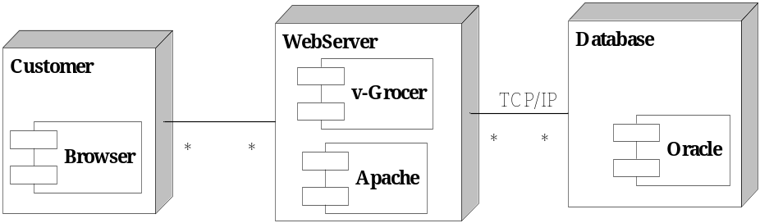
Figure 6.15 The combined component and deployment diagram for the v-Grocer. The software files are the Browser, v-Grocer, Apache, and Oracle, while the hardware components are the Customer, WebServer, and Database.
  - Project Application: Selecting Models
Chapters 5 and 6 have presented a variety of models for representing the behavior of systems. The design team needs to select the correct combination of tools to properly describe a design for its eventual implementation. Table 6.4 provides a summary of the models and their different intentions.
Table 6.4 Guidance for model selection.
Model | Intention
Functional Decomposition | To describe the input, output, and functional transformations applied to information (electrical signals, bits, energy, etc.) in a system. It is broad in application. This often provides a view that is close to the actual system implementation. See Chapter 5.
State Diagram | To describe the behavior of systems with memory. They are very flexible when it comes to application. They are often applied to digital design, but state diagrams can also be used to describe the high level behavior of complex systems. The only prerequisite on their use is that the system has memory. See Section 6.2.
Flowchart | To describe a process or algorithm, including its steps and control. They are applicable to many problem domains from software to describing business practices. See Section 6.3.
Data Flow  Diagram | To model the processing, transformation, and flow of data inside a system. They are typically supplemented by an event table describing all possible events and the resulting actions. Creating a DFD requires the designer to carefully think about the uses of the system and how the system is to react to external users and events. See Section 6.4.
Entity  Relationship  Diagram | To catalog a set of related objects (entities), their attributes, and the relationships between them. ERDs capture the entities and relationships of a portion of the world into a formal data model. The graphical language describes the attributes of the entities and the cardinality of the relationships. ERDs are formal enough to be unambiguously translated into a complete description of a database system. See Section 6.5.
The Unified Modeling Language. The intention of UML is to describe complex software systems. However, certain views are well suited to describing systems at a high level and are applicable to many domains. The process of viewing a system from the six perspectives listed below decreases the chances that crucial details of the design will be overlooked.
Class Diagram | To describe classes and their relationship in an object-oriented software system. Class diagrams are primarily for software design and are not easily accessible to a non-technical audience. See Section 6.6.1.
Use-Case  Diagram | To capture the overall behavior of the system from the user’s point of view and describe cases in which the system will be used. See Section 6.6.2.
State Machine | This is essentially the same as the state diagram, but is also a formal UML view. See Sections 6.2 and 6.6.3.
Activity  Diagram | To describe the sequencing of processes required to complete a task. Composed of states, transitions, forks, and joins. Can show concurrent processes. See Section 6.6.4.
Interaction  Diagram | To show the interaction and passing of messages between entities in a system. Characterized by both collaboration and sequence diagrams. See Section 6.6.5.
Physical  Diagram | To describe the arrangement and connections of the physical components that constitute a system. In the case of UML, it is characterized by a component and deployment diagram. See Section 6.6.6.
  - Summary and Further Reading
Models provide a convenient method of describing a system at a high level of abstraction. This allows a system to be described without having to determine all of the implementation details. All models are not the same—they come in a variety of forms and each is designed to serve a different intention. The properties of effective models were presented, and we saw that they are similar to those of an engineering requirement. Models should encourage innovation by allowing the exploration of alternative implementations. Since models are built from abstractions of the actual system components, they are an effective means for communicating with non-technical stakeholders. Finally, models provide an excellent means of documenting the development of a design from the highest level down to the detailed design.
This chapter presented a variety of models for describing system behavior that included state diagrams, flowcharts, data flow diagrams, entity relationship diagrams, and the Unified Modeling Language. Table 6.4 provides a quick reference that describes the intention and application of the models examined in both Chapters 5 and 6.
Flowcharts have been around for quite some time and an early work describing them is Flowcharts by Chapin [Cha71]. The book Programming Logic and Design [Far02] covers flowcharts extensively and their application in programming. State diagrams are fundamental to the ECE field and further information on them is available in virtually any introductory digital design textbook. Data flow diagrams and entity relationship diagrams are common tools used in information systems analysis and design and can be further explored in Systems Analysis and Design [Sat02] and Fundamentals of Database Systems [Elm94]. Two references for UML are The Unified Modeling Language Reference Manual [Rum98] and Schaum’s Outline of UML [Ben01].
  - Problems
  - Why is it important for a model to separate the design of a system from its realization?
  - Classify each of the following as either a model, not a model, or sometimes a model. Justify your answer based on the definition and properties of a model.
- A diagram of a subway system, b) a computer program, c) a football play, d) a drivers license, e) a floor plan of the local shopping mall (a “you are here” diagram)., f) an equation, g) A scratch n’ sniff perfume advertisement in a fashion magazine, h) The 1812 overture, i) a braille sign reading “second floor”, j) sheet music for the Brandenburg Concerto, k) the United States Constitution, l) a set of car keys, m) the ASCII encoding of an email message.
  - Which of the following systems has memory? Justify your answer using the concepts of input, output, and state.
- an ink pen, b) a resistor, c) a capacitor, d) a motorized garage door, e) an analog wrist watch, f) the air pressure in an air compressor, g) the thermostat which controls the furnace in a house, h) a light switch, i) a political system, j) the temperature of a large lake, k) a book, l) a computer’s hard drive.
  - A can of soda has memory. Your objective is to figure out what characteristic of the can is the state variable and what input causes it to change. Based upon this, draw a state diagram for a can of soda. Label the transition arcs with the input responsible for the transition. Hint: no special equipment is needed to elicit the change of state.
  - Consider the state diagram for the vending machine shown in Figure 6.2. Now assume that the system accepts nickels, dimes, and quarters. Also assume that it is capable of returning change to the user after a purchase. Create a state diagram that represents this new system. Make sure to define the output signals and their value for each state.
  - Use a state diagram to describe the high level operation of the ChipMunk Recorder (CMR). The CMR records sounds and then plays them back at a variety of speeds, making a recorded voice sound like a high pitched chipmunk. The CMR receives user input from a keyboard and an audio source. The behavior of the system is described as follows:
- When powered up, the CMR enters a wait state.
- If 'R' is pressed the recorder begins recording.
- Any key-press will put the CMR back into the wait state.
- If 'S' is pressed, the CMR is ready to change the playback speed. A subsequent numerical input between 1 and 5 will cause the playback speed to be changed to that value.
- Pressing the 'R' key when in the adjust playback speed mode will cause the CMR to go to the wait state.
- Pressing a 'P' key will cause the CMR to playback the recorded sounds. When done playing the entire recording, the CMR will loop back and start playing at the beginning.
- Any key-press while in the playback mode will cause the CMR to go back into the wait state.
Draw a state diagram describing the behavior of the CMR. Create a table which lists every state and its associated output.
  - Build a state diagram to describe the state of the tape cartridges used to backup a company’s network drives. When new unformatted cartridges are received they are immediately labeled with a unique ID. Before a tape is used it is formatted turning it into a blank tape. On the first day of the week a complete backup is made of the network drives, transforming blank tapes into active tapes. The active tapes, made every fourth week, are moved off site making them archival tapes. Active tapes older than 3 months are assumed to have out of date information and are reformatted into blank tapes. Archival tapes more than 2 years old are reformatted and put back into circulation.
  - Build a flowchart to describe the operation of a microcontroller (MCU) based temperature regulating system. The system monitors the temperature of a heated environment using thermistors and regulates the temperature by turning fans on to cool the environment. The MCU periodically reads the temperature from each of the 64 different thermistors (each is driven by its own constant current source) by selecting each through an analog multiplexor. The voltage is converted into an 8-bit digital value using the MCU’s analog-to-digital converter. If any of the 64 thermistors exceeds a high temperature threshold, the MCU uses a complex algorithm to determine the number of fans to turn on, otherwise all the fans are turned off.
  - Write an algorithmic description for each of the flow charts below using while, if, or do statements.
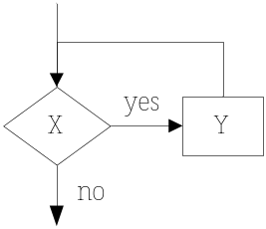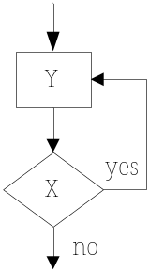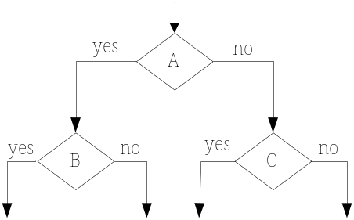
(a) (b) (c)

  - Create a flowchart that outlines how to crochet a two-tone blanket with a diagonal stripe across it as shown below. A blanket is crocheted by linking together a sequence of basic stitches. For the purposes of the flowchart assume that a basic stitch is an elaborate process. Basic stitches are made from either dark or light yarn. The blanket should be 100 stitches wide by 150 stitches high. The diagonal stripe runs at a 45 degree angle from the horizontal.

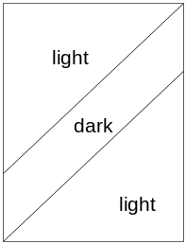

  - Build a data flow diagram and event table to represent an image archiving system for an art museum. The art museum maintains a database of digital images of paintings from museums all over the world. The following information is known about the image database system:
- Images are shared among museums in a participating network. Whenever a participating museum posts a new image, it sends a broadcast email to all participating museums in the network with the image attached as an email. It provides the name of the painting and artist in the body of the email. All new images received are added directly to the museum’s own image database.
- When inserted into the museum’s database, each image is provided with a tag identifying the name of the painting and the artist. Furthermore, this triggers an image analysis routine that classifies the image based into predefined categories such as portrait, natural scene, and modern. Furthermore, it stores key features that are extracted from the image.
- The key features are used to identify and retrieve visually similar images from the museum’s database. Another image processing algorithm is run that compares the visual similarity of the new image to all images in the database. This process produces a matching score of 0 to 100 that is stored.
- The museum’s image database is available to visitors via computer kiosks placed throughout the museum. Kiosk users can retrieve and view images in one of three ways. First, they can specify the name of the artist or painting. Second, they can retrieve a class of images, such as modern. Third, once they have received a painting, they can submit a request to view visually similar images. The visually similar images are retrieved for viewing based upon the matching score.
  - Build an ERD to keep track of the bicycle frames manufactured at a local company. The following are notes from an interview with the owner.
We custom build bike frames to the dimension of each individual customer. When a customer comes in we take measurements in their height, leg length, arm length, torso length, weight, and waist measurement. Since we have high customer satisfaction our customers order new frames every several year. Hence we would like to date these measurements in order to track how a customer’s body changes through time .Each frame is built on one set of measurements. Clearly, we need to keep track of our customer’s contact information like name, address, phone number, and email address. We would like to know which employee built which frame. We would like to store basic information like name, address, phone, and SSN for each employee. Each frame is built by one employee using a variety of different titanium tubing. We have strict inventory control on all of our tubing and need to keep track of its grade, lot #, Outer Diameter (OD), Inner Diameter (ID), and manufacturer. Tubing is uniquely identified by its lot #. Finally we need to keep information on the frame. Each frame is given a unique serial number, and has a color, type, and dimensions.
  - Extend Problem 6.7 to create an ERD that captures data about the tape cartridges used in the backup system. Every Sunday night a full backup is made of all network drives. A full backup creates an identical copy of the network drives on the tape cartridges. Due to the large amount of information, a full backup requires many tapes. On the other nights of the week an incremental backup is made. An incremental backup stores only files modified since the last backup (either full or incremental). Incremental backups are much smaller than a full backup, and consequently many incremental backups fit on a single tape. A tape contains only full or incremental backup information – the unused portion of the last tape used for a full backup is never used to store incremental backups. Your company wants to keep track of tapes, full backups, and incremental backups. An ID and state should be tracked for each tape. For full backups, the system needs to track the creation date and the number of tapes used. For an incremental backup it should track the date it was made. The relationships between the backup type and the tape will capture which tapes participated in which backup. (Hint: the state of a tape should be an attribute of the tape entity - unformatted, blank, etc. They are not attributes and are possible values for the state attribute.)
  - Project Application. Develop behavior models that are applicable for describing your system. Table 6.4 is provided to help in making the determination as to which models are applicable

